Msc project inspection

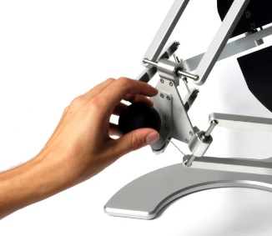Project aim:

* 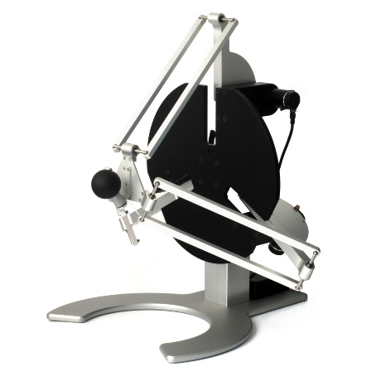Create a VR immersive environment where individuals with neurological conditions, such as developing sensory motor deficiency post stroke, can participate in exercises using a haptic device (delta robot, see figures)
  + Using the delta robot to provide force feedback during upper limb target reaching or target tracking
* This will provide force feedback while interacting with the VR rehabilitation exercises, which will promote motor skill improvement and overall rehabilitation outcomes
* The overall goal is to contribute to the field of neurorehabilitation by utilising virtual reality and haptic technology to facilitate rehabilitation of motor control
* Doing this project I hope to accelerate and enhance the rehabilitation process for patients with sensory motor deficiency and others in need of rehabilitation service

What the problem is

* This project aims to improve rehabilitation outcomes, specifically in the context of upper limb target reaching and target tracking tasks
* The field of rehabilitation has had significant advances in drug treatment; however this has resulted in greater number of patients requiring rehabilitation while health care budgets remain limited
  + This is because of the increase in individuals surviving conditions that lead to physiological impairments such as strokes, who then require rehabilitation
  + Aging population and increased prevalence of risk factors for stroke such as diabetes and hypertension having further increased the demand for rehabilitation services

How I’m going to tackle it

* Integration of technology: using virtual reality to create and immersive environment for therapy, making it more practical for patients to interact with engaging exercises in a realistic manner.
* Rewards and incentives: using rewards and creating a game like experience to keep patients engaged and encourage participation to help them keep motivated and achieve their rehabilitation goals
  + Using unity game engine to design and create the VR exercises, and applying these to the haptic devices
* Haptic feedback: haptic feedback (touch sense) will enhance the rehabilitation exercise. This can be achieved through the use of a delta robot which will provide force feedback to upper limbs. For example, supportive forces or resistive forces can be applied to assist the patient’s rehabilitation progress. This can be changed depending on the patient’s sensory motor ability
* Optimisation and data analysis: by leveraging advancements in data analytics and machine learning, clinicians can gain insights into the effectiveness of different therapies and personalise treatment plans based on individual characteristics

Focus: motion tracking (hand)

What are challenges and risks in the project

* Integration of the haptic devices, motion tracking systems could present technical difficulties. Ensuring these components are synchronised may require thorough testing and trouble shooting
* Choosing a focus point on what my project can produce with limited time availability
  + E.g use of hand tracking to monitor progress of patients or use of EEG to see which areas of the brain are stimulated
  + E.g designing and implementation of force feedback. Involves determining the appropriate supportive an resistive forces to be applied during tasks
  + Task customisation: tailoring difficulty level to the patients ability to ensure a personalised rehabilitation experience

Strategies for managing these risks

* Allocate sufficient time to integrate haptic devices and progress tracking systems. If I struggle seek out help and support to help solve these problems
* Research and breakdown focus points of my project and make a realistic choice as to which area will be realistic main focus, and which ones I may be minor focus for the over all project given the time frame I have

Evaluation

* Breaking my project down into smaller tasks with deadlines and ensuring I meet each mini deadline, with the project finishing before the deadline, allowing me time to write the report

10min presentation